Consortium Members

ESA Sea Level CCI

Validation Report: WP2300 Wet tropospheric correction
Reference: | CLS-DOS-NT-12-53
Nomenclature: | SLCCI-VR-21
Issue: | 1. 2
Date: | Mar. 12, 12

Chronology Issues:
Issue: | Date: | Reason for change: | Author
1.0 | 01/08/11 | Initialization | J.-F. Legeais
1.1 | 14/09/11 | Revision after B. Picard comments | J.-F. Legeais
1.2 | 12/03/12 | Minor corrections | M.Ablain

People involved in this issue:
Written by (*): | J.-F. Legeais (CLS) | Date + Initials:( visa or ref)
Checked by (*): | G Timms (Logica) | Date + Initial:( visa ou ref)
Approved by (*): | G Larnicol (CLS) | Date + Initial:( visa ou ref)
Application authorized by (*): | ESA | Date + Initial:( visa ou ref)
*In the opposite box: Last and First name of the person + company if different from CLS
Index Sheet:
Context: | Baghera tool, project ACT-OCEAN
Keywords: | Oceanography, sea level
Hyperlink:

Distribution:
Company | Means of distribution | Names
CLS | Notification

List of tables and figures

List of tables:
Aucune entrée de table d'illustration n'a été trouvée.
List of figures:
Figure 1: [Diagnosis A001] Monitoring of the mean difference between NCEP and the composite wet tropospheric correction for TOPEX/Poseidon mission 5
Figure 2: (Not in RRDP) Monitoring of wet path delay (opposite of the wet tropospheric correction) for JMR and MWR (Jason-1 and Envisat radiometers), ECMWF and NCEP models 5
Figure 3: [Diagnosis C003] Periodogram of SLA differences between altimetry (Jason-1) and tide gauges using NCEP wet tropospheric correction and the composite reference correction. 6
Figure 4: [Diagnosis A204-a] Map of the MSL trend differences using the wet tropospheric correction derived from the ERA Interim and the ECMWF models for Envisat mission. 8
Figure 5: : [Diagnosis A204-a] Map of the MSL trend differences using the wet tropospheric correction derived from the NCEP and the reference composite correction. 8
Figure 6: [Diagnosis A205] Amplitude (left) and phase (right) differences of regional MSL annual signals using ECMWF correction versus the composite reference for Envisat mission. 9
Figure 7: [Diagnosis A205] Amplitude (left) and phase (right) differences of regional MSL annual signals using NCEP correction versus the composite reference for Envisat mission. 10
Figure 8: Mean differences between wet tropospheric corrections derived from ERA Interim and ECMWF models for Envisat mission. 11
Figure 9: [Diagnoses A102 –adapted from RRDPs, A104] Monitoring of the SSH variance differences at crossover points with models versus composite correction for TOPEX/Posidon (left) and map of the SSH variance differences at crossover points using successively ECMWF wet tropospheric correction and the composite reference for Envisat mission. 12

List of items to be confirmed or to be defined

Lists of TBC:
Aucune entrée de table des matières n'a été trouvée.
Lists of TBD:
Aucune entrée de table des matières n'a été trouvée.
Applicable documents
AD 1 Sea level CCI project Management Plan
CLS-DOS-NT-10-013
Reference documents
RD 1 Manuel du processus Documentation
CLS-DOC
List of Contents
1. Introduction 1
1.1. Wet tropospheric corrections derived from models 1
1.2. Wet Troposphere corrections derived from radiometers 2
2. Global Mean Sea Level 2
2.1. Long-term evolution 2
2.1.1. Validation diagnoses used 2
2.1.2. Wet Troposphere corrections derived from models 2
2.1.3. Wet Troposphere corrections derived from radiometer 4
2.2. Inter-annual signals 4
2.2.1. Validation diagnoses used 4
2.2.2. Wet Troposphere corrections derived from models 4
2.2.3. Wet Troposphere corrections derived from radiometer 5
2.3. Annual and semi-annual signals 5
2.3.1. Validation diagnoses used 5
2.3.2. Wet Troposphere corrections derived from models 6
2.3.3. Wet Troposphere corrections derived from radiometers 6
3. Regional Mean Sea Level 7
3.1. Long-term evolution 7
3.1.1. Validation diagnoses used 7
3.1.2. Wet Troposphere corrections derived from models 7
3.1.3. Wet Troposphere corrections derived from radiometers 9
3.2. Annual and semi-annual signals 9
3.2.1. Validation diagnoses used 9
3.2.2. Wet Troposphere corrections derived from models 9
3.2.3. Wet Troposphere corrections derived from radiometers 10
3.3. Coastal areas 10
3.3.1. Wet Troposphere corrections derived from models 10
3.3.2. Wet Troposphere corrections derived from radiometers 11
3.4. High latitudes 11
3.4.1. Wet Troposphere corrections derived from models 11
3.4.2. Wet Troposphere corrections derived from radiometers 11
4. Mesoscale 12
4.1. Validation diagnoses used 12
4.1.1. Global analyses 12
4.1.1.1. Wet Troposphere corrections derived from models 12
4.1.1.2. Wet Troposphere corrections derived from radiometers 13
4.2. Coastal areas 13
4.2.1. Wet Troposphere corrections derived from models 13
4.2.2. Wet Troposphere corrections derived from radiometers 14
4.3. High latitudes 14
4.3.1. Wet Troposphere corrections derived from models 14
4.3.2. Wet Troposphere corrections derived from radiometers 14
5. Conclusions and recommendations 14
Appendix A - Synthesis 15
5.1. ERS-1 16
5.2. ERS-2 17
5.3. Envisat 18
5.4. TOPEX/Poseidon 19
5.5. Jason-1 20
Appendix B - Definition of the indicator value 21
Appendix C - List of acronyms 22

Introduction
The main objective of this document is to provide the analysis of the Round Robin Data Packages (RRDP) reports dedicated to the wet tropospheric correction (also called path delay) (WP2300) in order to estimate the best algorithm to compute this correction and improve the sea-level computation for climate applications.
Most of the time, the wet tropospheric corrections used in the sea-level estimation are derived from on board microwave radiometer for all satellite altimeter. The correction can be also derived from models, however the performances of this correction are better when retrieved from instrumental measurements at a global scale, with respect to precision, sensitivity and spatial sampling. The modelled corrections are thus generally not used to calculate the best sea-level height but they remain one of the few references to assess the quality of the radiometric corrections in terms of performances or stability.
Therefore our strategy in this study is to compare separately the wet tropospheric corrections derived from models and from radiometer. The aim is to detect the best modeled wet tropospheric correction in order to assess radiometric stability and performances.
This document discuss the impact of all new algorithms separating the different climate applications defined in the sea level CCI URD (User Requirement Document) and separating the several temporal scales related with climate applications. A clearly and easily understandable impact indicator has been defined and is described in annex of this document (see Appendix B -).

Wet tropospheric corrections derived from models
The following Round Robin Data Packages (RRDP) reports have been performed for various missions:
- Comparison of the wet tropospheric correction computed from operational ECMWF model with the composite correction for ERS-2 and Envisat missions:
RRDP_WP2300_WetTropo_ECMWF_vs_COMPOSITE_11-08-31.pdf
- Comparison of the wet tropospheric correction computed from ERA Interim reanalyses with the composite correction and with ECMWF model:
RRDP_WP2300_WetTropo_ERAINT_vs_RWT_11-08-30.pdf for TOPEX/TOPEX/Poseidon, ERS-1 and ERS-2 missions
RRDP_WP2300_WetTropo_ERAINT_vs_ECMWF_11-08-31.pdf for TOPEX/Poseidon, Jason-1 and Envisat missions
- Comparison of the wet tropospheric correction computed from NCEP reanalyses with the composite correction for ERS-1, ERS2, Envisat, Jason-1, Jason-2 and TOPEX/Poseidon missions:
RRDP_WP2300_WetTropo_NCEP_vs_COMPOSITE_11-08-26.pdf

The ECMWF wet tropospheric correction is produced by EUMETSAT using 3D data from the ECMWF model to generate wet troposphere values. The reference composite wet tropospheric correction used as in sea level AVISO products is computed as follow:
- For ERS-1, the wet tropospheric correction retrieved from the radiometer measurements (from OPR products) is used offshore 50km while ECMWF operational model is used inshore
- for ERS-2, the wet tropospheric correction retrieved from the radiometer measurements (neuronal approach) is used offshore 50km and the ECMWF operational model is used inshore
- for Envisat, TOPEX/Poseidon, ERS1, Jason-1 & 2: the wet tropospheric correction retrieved from the radiometer measurements (from GDR-C products) is used offshore 50 km while ECMWF operational model is used inshore

For all missions, values from the model inshore 50km are adjusted on the radiometric wet tropospheric correction to provide continuity of the correction.

The ERA Interim wet tropospheric correction is based on the ERA INTERIM model which corresponds to the latest global atmospheric reanalysis produced by the European Centre for Medium-Range Weather Forecasts (ECMWF)(The ERA-Interim reanalysis: configuration and performance of the data assimilation system. Q. J. R. Meteorol. Soc. 137: 553-597, April 2011 A).

The NCEP Reanalyses are provided by the NOAA-CIRES Climate Diagnostics Center, Boulder, Colorado, USA, and are available from their Web site at http://www.cdc.noaa.gov/. NCEP reanalyses are available over the whole altimetric period (1992 onwards) and are thus adapted to assess the temporal stability of the correction in particular for missions of the 90s’ (ERS-1 & 2, TOPEX/Poseidon).

Wet Troposphere corrections derived from radiometers
In the Sea-level CCI project, it is planned to develop a new radiometric correction for all atlimetric missions in order to improve the long-term stability of the correction. This correction is not yet available. Therefore the RRDP report has not been yet performed.
Besides, in task WP2700 dedicated to coastal areas, a new wet tropospheric correction mixing radiometer, models and GNSS data has been developed at the University of Porto, Faculty of science (J. Fernandes). The RRDP relative to this new correction has been analyzed and described in the validation report relative to WP2700 dedicated to coastal areas.

Global Mean Sea Level

Long-term evolution

Validation diagnoses used
The validation diagnostic of the long-term sea-level evolution (A201-a) allows us to evaluate the impact on the global MSL trend using successively the different wet tropospheric corrections. Their impact is also analyzed separating descending and ascending passes (A201-b): the reduction of the MSL trend differences obtained separating descending and ascending passes is a good quality criterion to determine which correction is the best one. Cross-comparison of MSL trends between altimetric missions collocated on the same period (B001) and the comparison with in-situ measurements (tide gauge) also give a relevant indication to know whether the potential drift of altimeter MSL is reduced or not with new correction (C001).

Wet Troposphere corrections derived from models
The following table indicates the impact of the modeled wet tropospheric corrections on global MSL trends. Several RRDPs may have been generated on different periods of a single altimetric mission. Indeed, the operational ECMWF model has been particularly improved after the 2000’s and the model has thus been analyzed separating the periods of some altimetric missions before and after this time (see the left column of table 1):
- Compared with the composite correction currently used in AVISO products, the wet tropospheric correction derived from ECMWF has a significant impact on the global MSL trend estimations of ERS-2 and Envisat missions (+0.2 and +0.5 mm/yr respectively).
- The use of ERA Interim wet tropospheric correction compared with the composite reference correction has a significant impact on the global MSL trend of ERS-1 and ERS-2 missions and a low impact for TOPEX/Poseidon (cf Table 1). The stronger impact on ERS-1 (-0.6mm/yr) is likely due to the shorter altimetry period used for this mission (October 1992 -June 1996).
- As the use of ECMWF and ERA Interim wet tropospheric corrections have a similar impact on the global MSL trend estimation, we compare both models with each other. The comparison of ERA-Interim re-analyses with operational ECMWF model indicates that the impact of using one or the other version of the model on the global MSL trend estimation is weak for Envisat (0.1 mm/yr) and significant for Jason-1 (0.2 mm/yr) and TOPEX/Poseidon (0.5 mm/yr) (cf table 1).
- The use of the wet tropospheric correction derived from NCEP reanalyses compared with the reference composite correction has a significant impact on the MSL trend estimation for ERS-1, Envisat and Jason-1 and a rather low impact for ERS-2 and TOPEX/Poseidon.

Altimetric missions | Composite correction | ECMWF | ERA Interim | NCEP
ERS-1 | 6.2 mm/yr |  | 5.6 mm/yr  (-0.6 / Composite) | 5.5 mm/yr  (-0.7 / Composite)
ERS-2 (1:85) | 2.6 mm/yr |  | 2.4 mm/yr  (-0.2/Composite) | 2.5 mm/yr  (-0.1/Composite)
ERS-2 (49:163) | 1.6 mm/yr | 1.8 mm/yr  (+0.2 / Composite)
Envisat (9:93) | 0.6 mm/yr | 1.1 mm/yr  (+0.5/Composite) |  | 1.3 mm/yr  (+0.7/Composite)
Jason-1 (2:330) | 2.5 mm/yr |  |  | 3.0 mm/yr  (+0.5/Composite)
TOPEX/Poseidon (11:480) | 3.1 mm/yr |  | 3.0 mm/yr  (-0.1/Composite) | 3.0 mm/yr  (-0.1/Composite)
Envisat (9:84) |  | 1.4 mm/yr | 1.5 mm/yr  (+0.1/ECMWF)
Jason-1 (2:293) |  | 2.7 mm/yr | 2.9 mm/yr  (+0.2/ECMWF)
TOPEX/Poseidon (344:480) |  | 2.7 mm/yr | 3.2 mm/yr  (+0.5/ECMWF)
Table 1: [Diagnosis A201-a] Impact of the modelled wet tropospheric corrections on global MSL trends. Blue boxes are the reference used in the corresponding RRDP.

Notice that in theory, the comparison of ascending/descending trend differences may contribute to assess whether the observed evolution of the trend is an improvement or not. But in case of the wet tropospheric correction, the impact of each solution is not significant. Therefore, in this case it is not an adapted quality criterion.
Concerning the comparison with tide gauges, the estimation of the Envisat MSL drift using each wet tropospheric correction is no relevant due to the strong drift observed on Envisat. This drift is not related with the wet tropospheric correction but likely to instrumental (altimeter) corrections (see validation report of WP2100 – instruments correction).
To sum up, depending on the altimetric mission considered (and the length of its time series), the modelled wet tropospheric correction may have a significant impact on the global MSL trend estimation. Nevertheless, no diagnosis performed in RRDP report shows that these differences are an improvement.

Wet Troposphere corrections derived from radiometer
Not yet performed.

Inter-annual signals

Validation diagnoses used
The monitoring of the differences between both corrections (A001) but also of the variance differences of SLA (A202) may provide information concerning the impact of the studied correction on the global MSL at inter-annual time scales.

Wet Troposphere corrections derived from models
ERS-1 period is too short (4 years) to detect any inter-annual differences due to one of the studied wet tropospheric correction. For other missions, their period of study may be long enough but with the use of ECMWF or ERA-interim wet tropospheric correction, no variation is clearly observed at time scales higher than 1 year.
Nevertheless, concerning NCEP reanalyses, the monitoring of the difference of the correction with the composite correction (A001) reveals a jump of this difference in 1998 for both TOPEX/Poseidon (3mm, Figure 1) and ERS-2 (5mm) missions, possibly associated with ENSO event which has been considered differently with both algorithms.
Similarly, concerning the comparison between ECMWF and ERA-Interim corrections, a 2mm jump is observed in 2008 for Envisat and Jason-1 missions (annual signal included) (A001). It may be associated with the 2008 ENSO event which has been considered differently with these two models.

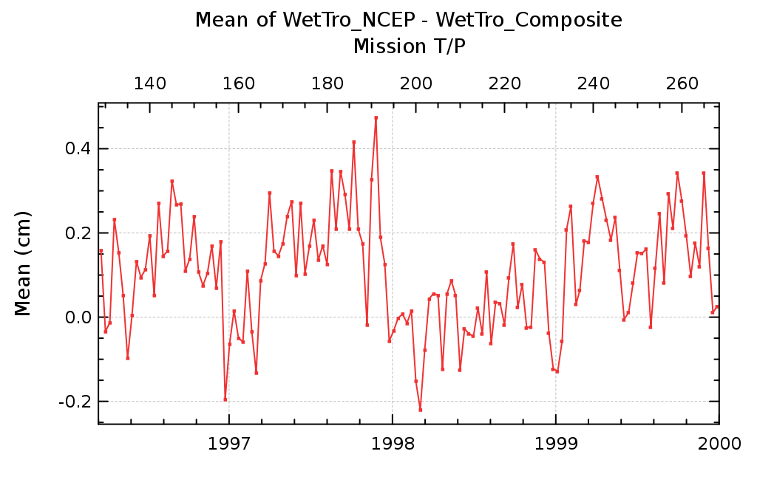
Figure 1: [Diagnosis A001] Monitoring of the mean difference between NCEP and the composite wet tropospheric correction for TOPEX/Poseidon mission
This difference of behaviour between ECMWF and NCEP corrections concerning this inter-annual effect of the 2008 ENSO event is also detected on the monitoring of the wet path delay as seen by radiometers, ECMWF and NCEP (Figure 2). NCEP reanalyses time series presents a similar evolution as radiometers in 2008 whereas ECMWF model doesn’t take into account this natural evolution of the water vapour content. As expected, the operational model doesn’t reproduce inter annual signal as well as with the NCEP reanalyses.
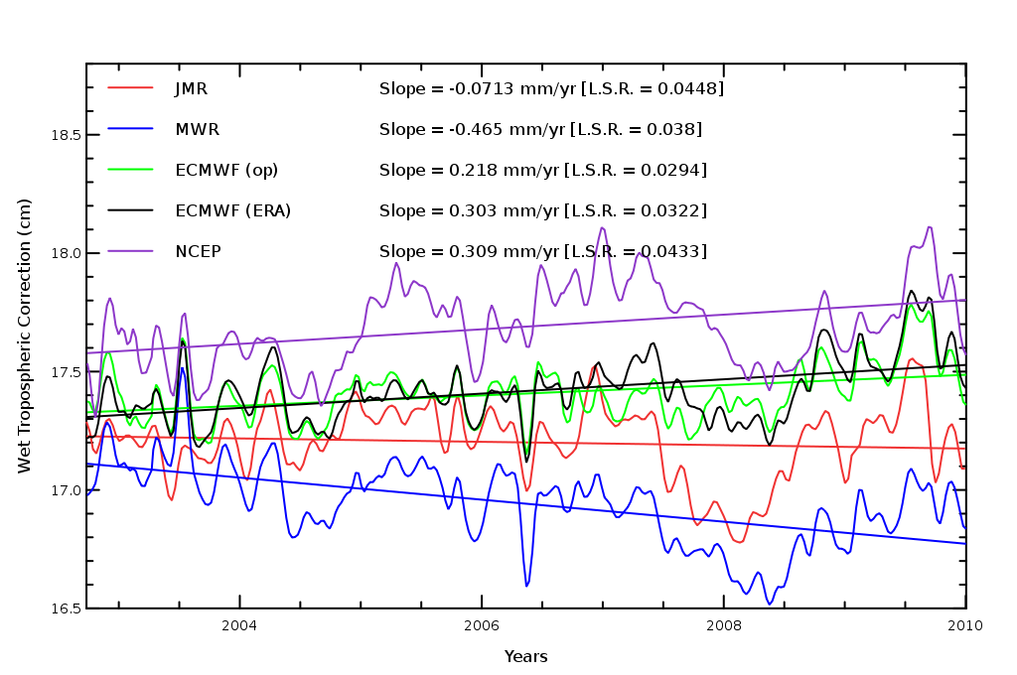
Figure 2: (Not in RRDP) Monitoring of wet path delay (opposite of the wet tropospheric correction) for JMR and MWR (Jason-1 and Envisat radiometers), ECMWF,ERA and NCEP models

Wet Troposphere corrections derived from radiometer
Not yet performed.

Annual and semi-annual signals

Validation diagnoses used
The periodograms of differences between two different wet tropospheric corrections allow us to determine the impact of the studied correction at annual and semi-annual scales (A003). Analyzing the difference of sea-level periodograms (A206), we can describe which correction allows us to reduce the periodic signals. Generally, a reduced annual or semi-annual amplitude signal in the SLA computation is a good indication of a better correction. The comparison with in-situ measurements (tide gauge) also gives a relevant indication of whether the periodic signals are reduced or not with the new correction (C003).

Wet Troposphere corrections derived from models
When compared with the reference composite correction, the operational ECMWF model has a significant impact on the annual signal amplitude of ERS-2 and a low impact for Envisat. The use of ERA Interim has a significant impact on the annual signal amplitude for ERS-2 and a low impact for ERS-1 and TOPEX/Poseidon. The comparison of SLA periodograms (A206) indicates that the annual signal amplitude is significantly reduced with ERA Interim compared with the composite correction for ERS-2. Periodogram of the annual amplitude of the altimetric SSH compared with tide gauges (C003) suggests that the use of the correction retrieved from radiometer measurements provides more homogeneity with the in-situ reference rather than with ECMWF correction for Envisat.
The impact of ERA Interim re-analyses compared with ECMWF on the annual signal amplitude is low for Jason-1 (0.4 mm) and Envisat (0.5 mm) and no impact is detected for TOPEX/Poseidon.
The impact of NCEP reanalyses compared with the composite correction on the annual signal amplitude of the difference (A003) is low for all studied missions: ERS-1 (0.9mm), ERS-2 (0.9mm), Envisat (0.5mm), Jason-1 (0.8 mm) and TOPEX/Poseidon (0.9 mm).
The comparison of SLA periodograms with both corrections (A206) indicates that the amplitude of the annual signal of SLA is not impacted by the use of the NCEP correction for all studied missions. Nevertheless a reduced amplitude is detected when focusing on the southern hemisphere. This is likely due to the greater ocean coverage in this hemisphere.
Periodograms of the altimetric versus in-situ (from tide gauges) SSHs with NCEP correction and the composite reference (Figure 3) indicate that the amplitude of the annual signal is more coherent with in-situ data with the use of NCEP reanalyses for both Jason-1 (1.5mm) and TOPEX/Poseidon (1.0mm) missions, suggesting that annual signal is better taken into account in NCEP reanalyses.
At last, according to the altimetric mission, the use of the wet tropospheric correction derived from ERA Interim and NCEP reanalyses may provide a better estimation of the annual signal amplitude and thus better correct this signal in the SLA computation. Otherwise, no significant impact is detected with models compared with the reference composite correction.

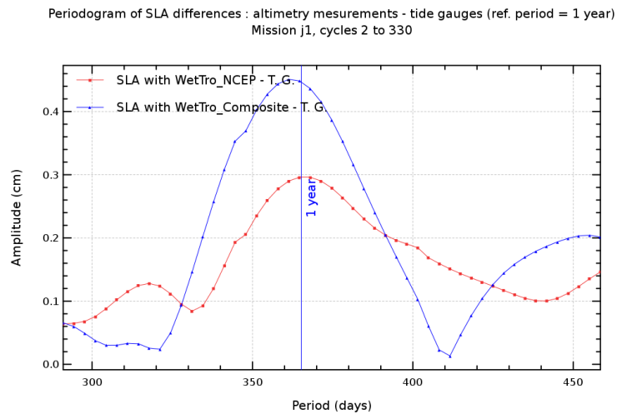
Figure 3: [Diagnosis C003] Periodogram of SLA differences between altimetry (Jason-1) and tide gauges using NCEP wet tropospheric correction and the composite reference correction.

Wet Troposphere corrections derived from radiometers
Not yet performed.

Regional Mean Sea Level

Long-term evolution

Validation diagnoses used
The validation diagnosis of the regional trend of sea-level differences using successively two wet tropospheric corrections (A204a) allows us to evaluate the impact of the different corrections on the local MSL trends. Their impact is also analyzed separating descending and ascending passes (A204-b): the reduction of the MSL trend differences obtained separating descending and ascending passes is a good quality criterion to determine which correction is the best one. Cross-comparison of MSL trends evolution between altimetry missions collocated on the same period (B202) may also give a relevant indication of whether the MSL drift difference between both altimetric missions is reduced or not with the use of the studied correction.

Wet Troposphere corrections derived from models
The impact of using the wet tropospheric correction derived from ECMWF instead of the reference composite correction on the long term evolution of the regional MSL is mainly detected at low and mean latitudes for ERS-2 (A204a). The MSL trend obtained with ECMWF model in these regions is lower than with the reference by more than 2 mm/yr.
For Envisat, the impact of using the correction derived from ECMWF instead of the reference composite correction is mainly detected at equatorial latitudes with a higher MSL trend obtained with ECMWF of more than 1 mm/yr. In the subtropical and subpolar gyres, the impact is also significant (1 mm/yr of difference) but with a smaller MSL trend obtained with ECMWF.
The impact on ERS-1 of using the wet tropospheric correction derived from ERA-Interim re-analyses instead of the reference composite correction on the long term evolution of the regional MSL is detected over the whole ocean with a generally lower MSL trend obtained with the model (by more than 1 mm/yr). A similar impact is observed for ERS-2 but limited to low and mean latitudes.
For TOPEX/Poseidon mission, the impact is observed at low and mean latitudes with a lower MSL trend obtained with ERA Interim but the amplitude of the difference is slightly smaller than for ERS missions (between 0.5 mm/y and 1 mm/y).
The cross-comparison of MSL trends from ERS-2 and TOPEX/Poseidon collocated on the same period reveals a strong hemispheric bias of +/- 5 mm/y: MSL trend is lower (5 mm/y) with T/P in the southern hemisphere whereas it is higher (5 mm/y) in the northern hemisphere. The impact of using the ERA Interim correction or the reference doesn’t modify this bias suggesting that it is an orbit related effect which dominates any impact of the wet tropospheric correction.

Concerning the ERA-Interim vs ECMWF wet tropospheric correction comparison, the impact on the long-term evolution of the regional MSL is not limited to low latitudes but is significant over the global ocean similarly for Envisat, Jason-1 and TOPEX/Poseidon missions (Figure 4, A204-a): the MSL trend with ERA-Interim is higher (by more than 0.5 mm/y) at mean latitudes and over eastern boundaries whereas it is lower (by more than 0.5 mm/y) at low and high latitudes. This is directly associated with differences of both models, particularly over the upwelling areas of eastern boundaries.
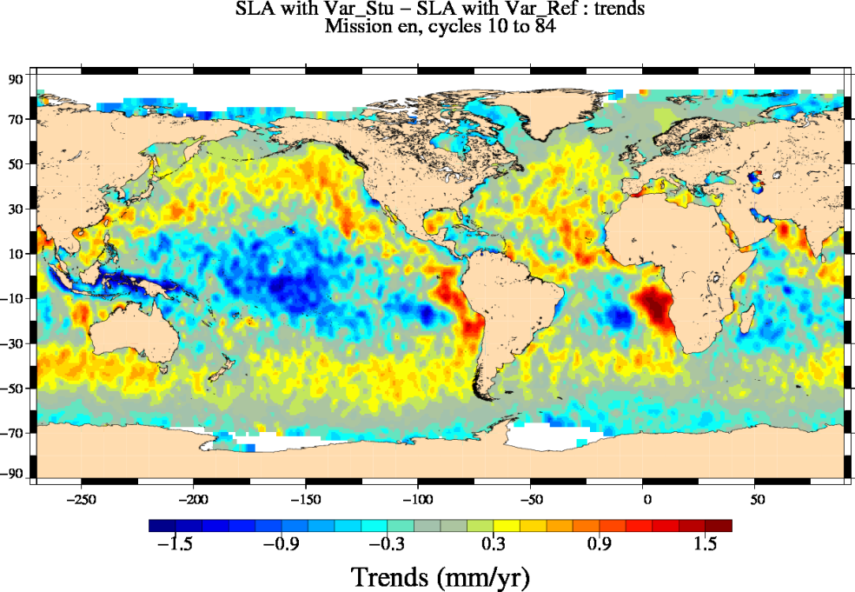
Figure 4: [Diagnosis A204-a] Map of the MSL trend differences using the wet tropospheric correction derived from the ERA Interim and the ECMWF models for Envisat mission.
The impact of using the wet tropospheric correction derived from NCEP reanalyses instead of the reference composite correction on the long term evolution of the regional MSL is only detected at low latitudes (<30°) for all studied missions (Figure 5, A204-a). In this latitudinal band, areas of alternatively positive and negative SLA trend differences are found. The sign of these trends differences varies from one mission to the other according to the period of study. The amplitude varies from ±10 mm/y for ERS-1, ±2 mm/y for TOPEX/Posiedon and ±4 mm/y for ERS-2, Envisat and Jason-1 missions. The same impact is detected separating ascending and descending passes.
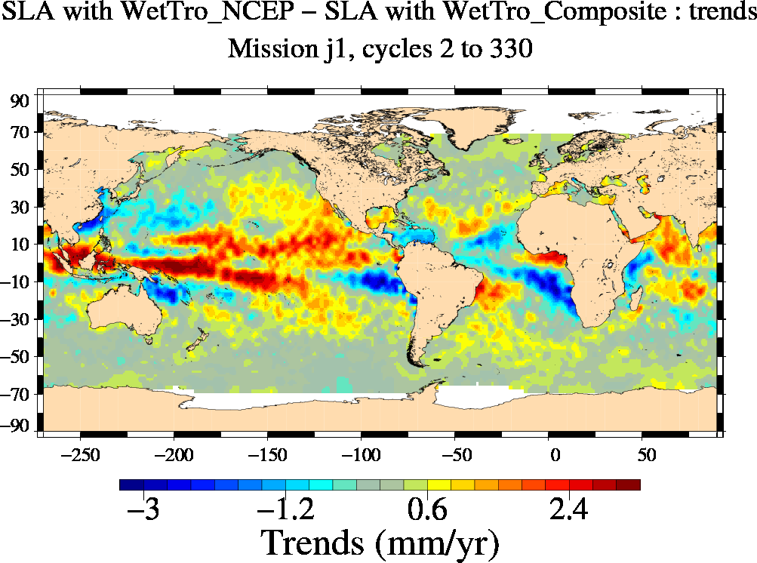
Figure 5: : [Diagnosis A204-a] Map of the MSL trend differences using the wet tropospheric correction derived from the NCEP and the reference composite correction.
The cross-comparison of MSL trends from ERS-2 and TOPEX/Poseidon and from Envisat and Jason-1 collocated on the same period (B202) reveal strong hemispheric biases which are related with orbit effect and thus dominate any effect of the wet tropospheric correction.
Thus using one of the modeled wet tropospheric correction instead of the composite reference has systematically a significant impact on the trend estimation of the regional MSL, particularly at low and mean latitudes, where the water vapor content is the most important. The regional analyses suggests that compared with the reference correction, the impact of using ERA Interim reanalyses is smaller than with the use of NCEP reanalyses. But no diagnosis allows us to assess if the observed evolutions are an improvement.

Wet Troposphere corrections derived from radiometers
Not yet performed.

Annual and semi-annual signals

Validation diagnoses used
The analyses of periodic signals of regional mean sea level are performed thanks to diagnostic A205 where the difference of amplitudes and phases between SLA using successively two wet tropospheric corrections are mapped for annual and semi-annual signals. These diagnostics allow us to characterize the local or regional impact of new corrections.
The comparison with in-situ measurements (temperature and salinity profiles for instance) also give a relevant indication of whether the periodic signals are regionally better estimated or not with the studied correction. At the moment this diagnostic has not been yet processed.

Wet Troposphere corrections derived from models
The amplitude differences of annual signals have been mapped using each modelled wet tropospheric correction versus the composite reference. Similar results are obtained with ECMWF, ERA Interim or NCEP wet tropospheric corrections and an example is shown on Figure 6 (left – A205) for Envisat mission with the use of ECMWF correction compared with the composite reference. The use of a modelled correction significantly impacts (>5mm) the amplitude of the annual signal mainly at mean latitudes (reduction of the amplitude) and in some areas at low latitudes (with an increased amplitude of the annual signal). The phase difference of the annual signal (Figure 6, right – A205), indicates that the use of a modelled correction has no impact on the phase of the annual signal.
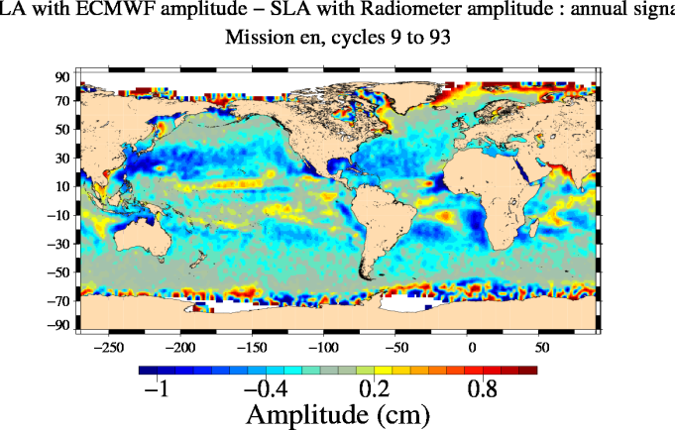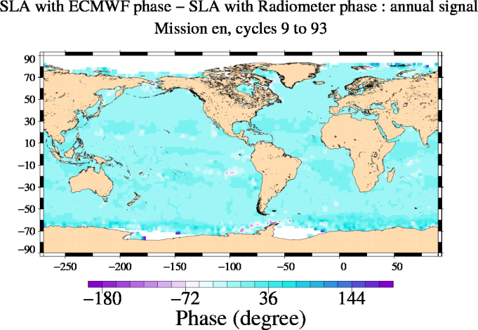
Figure 6: [Diagnosis A205] Amplitude (left) and phase (right) differences of regional MSL annual signals using ECMWF correction versus the composite reference for Envisat mission.
The use of NCEP modeled wet tropospheric correction has a similar impact on the amplitude of the annual signal (Figure 7, left) but contrary to other studied models, it modifies the phase of this signal (Figure 7, right). It generates a phase opposition (+/-180°) at subtropical latitudes. As such evolution is only observed with NCEP reanalyses, we suggest that it may be considered as a deterioration of the annual signal estimation of the regional MSL.

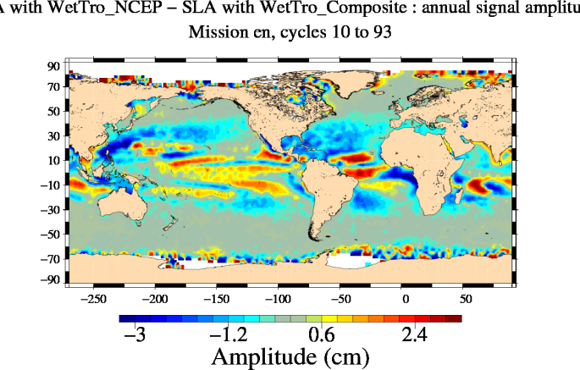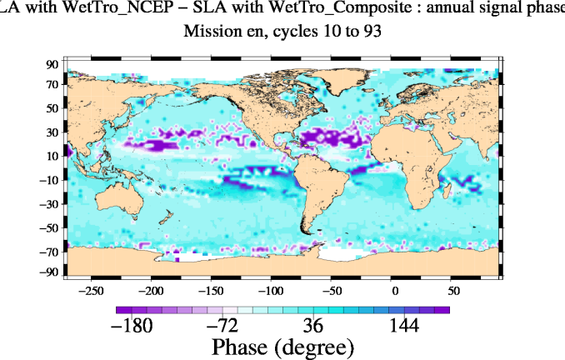
Figure 7: [Diagnosis A205] Amplitude (left) and phase (right) differences of regional MSL annual signals using NCEP correction versus the composite reference for Envisat mission.
Concerning the semi-annual signal, the modification of its amplitude is less pronounced than the one of the annual signal but it presents a similar spatial distribution (A205). The use of NCEP generates an opposition of phase of this semi-annual signal in some regions which is not observed with other modeled corrections.

Wet Troposphere corrections derived from radiometers
Not yet performed.

Coastal areas

Wet Troposphere corrections derived from models
The restitution algorithms of the wet tropospheric correction provide erroneous values in coastal areas due to the contamination of brightness temperatures by land. Modeled corrections usually provide more accurate values in coastal areas than the radiometer. That is the reason why the composite correction has been generated and is currently used in altimetric products.
Note also that differences between both corrections computed from ECMWF and ERA Interim (Figure 8, A002) are of the order 1 cm and are mainly located in areas of coastal upwellings of eastern boundaries. Figure 4 (A204-a) indicates that it directly impacts the MSL trend estimation in these coastal regions.
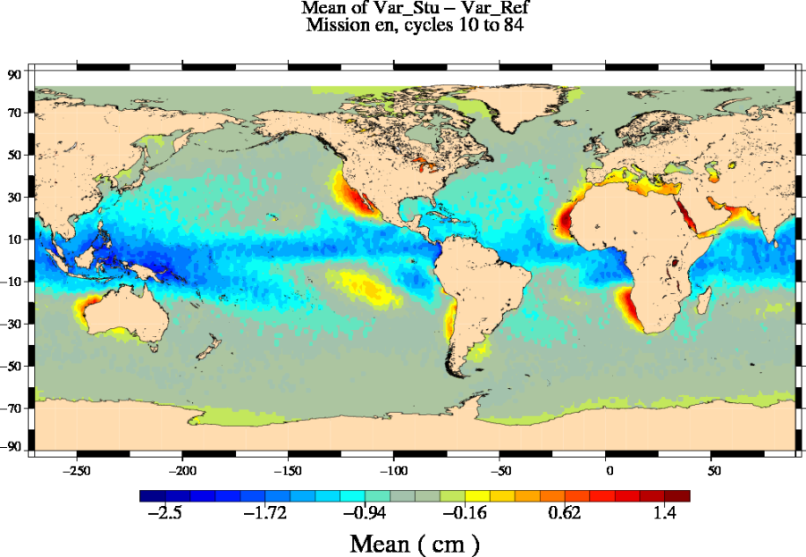
Figure 8: Mean differences between wet tropospheric corrections derived from ERA Interim and ECMWF models for Envisat mission.
Dedicated diagnoses (statistics according to the coastal distance) are not yet available to discuss the coastal impact of the studied wet tropospheric corrections more precisely.
As already mentioned in introduction, a specific algorithm of restitution of a coastal wet tropospheric correction has been produced in WP 2700. A dedicated validation report has been produced.

Wet Troposphere corrections derived from radiometers
Not yet performed.

High latitudes

Wet Troposphere corrections derived from models
As water content of the troposphere decreases with latitude, the value itself of the wet tropospheric correction is higher at low latitudes. The importance of the wet tropospheric correction at high latitudes is thus relatively low, particularly concerning long term evolution of the MSL.
Maps of SLA trends differences (A204-a) indicate that the use of all modeled wet tropospheric corrections compared with the composite reference have a significant impact on the MSL trend estimation at high latitudes (>66°) for ERS-1, ERS-2 and Envisat missions. It is not detected with TOPEX/Poseidon and Jason missions for latitudes lower than 66°. This is related with the ice-covered areas which degrade the performance of the path delay retrieval from radiometer measurements and thus generate major differences with modeled wet tropospheric corrections, impacting the estimation of the MSL trends in these regions.

Wet Troposphere corrections derived from radiometers
Not yet performed.

Mesoscale

Validation diagnoses used
Along-track sea-level analyses and differences at crossover points allow us to detect improvements at short temporal scales (< 2months) for mesoscale applications. The most relevant diagnostics performed in RRDP are the monitoring and the map of the variance SSH differences using successively 2 different wet tropospheric corrections.
Diagnostics A102 and A104 display the monitoring and the map of SSH variance differences at crossover points: the reduction of variance indicates a better homogeneity of the sea-level between ascending and descending tracks within a 10-day window.
Diagnostics A203 and A209 display the monitoring and the map of SSH variance differences relative to a mean sea surface (MSS): the reduction of variance indicates a better homogeneity with the MSS. Most of the time, it indicates an improvement of the sea-level computation. But note that in few cases, the variance increase can also indicate a systematic error in the MSS due to geographical bias for instance.

Global analyses

Wet Troposphere corrections derived from models
As expected and mentioned in introduction, the use of all modeled corrections compared with the composite reference generates a significant deterioration of the SSH coherence between ascending and descending passes for all altimetric missions as shown by analyses at crossovers points (Figure 9, A102, A104). The average deterioration depends on the period, on the mission and on the model. But on average for TOPEX/Poseidon mission, we observe a variance increase with models of 1.5 cm² with ERA Interim (Figure 9), 3.9 cm² with the operational ECMWF and 6.8 cm² with NCEP reanalyses. This demonstrates the importance of the availability of an on board microwave radiometer on satellite altimeters. In particular, Figure 9 (left) indicates that ERA Interim clearly provides the best performances before year 2000. After this time, the ECMWF operational model has benefited from significant improvements. In spite of these improvements, the ERA Interim reanalyses still provides the best performances after the 2000’s (1 cm² difference) as plotted in Figure 10..
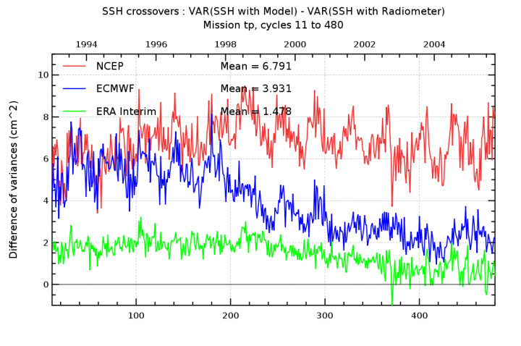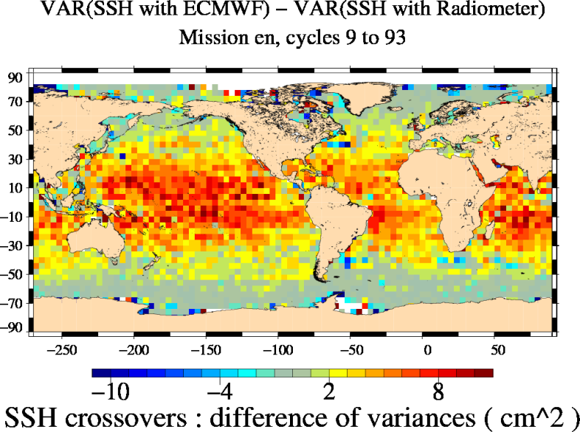
Figure 9: [Diagnoses A102 –adapted from RRDPs, A104] Monitoring of the SSH variance differences at crossover points with models versus composite correction for TOPEX/Poseidon (left) and map of the SSH variance differences at crossover points using successively ECMWF wet tropospheric correction and the composite reference for Envisat mission.

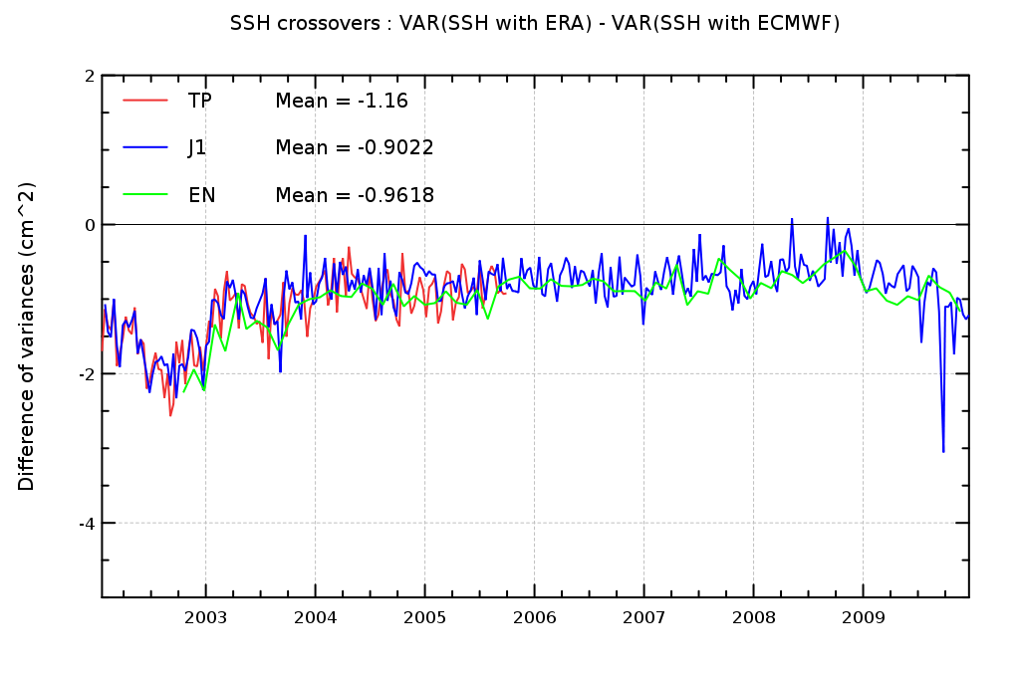
Figure 10: [Diagnoses A102 –adapted from RRDPs, A104] Monitoring of the SSH variance differences at crossover points with ERA-interim versus ECMWF (operational) from 2002 onwards for TOPEX/Poseidon, Jason-1, Envisat

Wet Troposphere corrections derived from radiometers
Not yet performed.

Coastal areas

Wet Troposphere corrections derived from models
As mentioned before, the restitution algorithms of the wet tropospheric correction provide erroneous values in coastal areas due to the contamination of brightness temperatures by land. Modeled corrections usually provide more accurate values in coastal areas than the radiometer. That is the reason why the composite correction has been generated and is currently used in altimetric products. Nevertheless concerning mesoscale applications, no specific impact of the modeled wet tropospheric corrections compared with the composite reference is detected in coastal areas compared with the open ocean. Figure 9 (A104) shows that coastal regions are impacted but this is not associated with coastal distance dependence.
Nevertheless, note a specific coastal region of improvement of the short temporal signals located around the Spitsberg Island in the Arctic Ocean. It is systematically detected with all modeled correction compared with the composite reference (cf Figure 9 for an example with ECMWF correction).
Moreover, some diagnoses performed in the framework of the work package 2700 (coastal wet tropospheric correction) indicates that the composite reference correction currently used in Aviso products provides a deterioration of the estimation of the mesoscale signals compared with the radiometric correction in coastal areas (<100km offshore).

Wet Troposphere corrections derived from radiometers
Not yet performed

High latitudes

Wet Troposphere corrections derived from models
Maps of the SSH variance differences at crossover points indicates that all the modeled wet tropospheric corrections have no impact on the estimation of mesoscale activity at high latitudes (especially compared with lower latitudes), as shown on Figure 9.
As mentioned above, a specific restricted region of improvement with the modeled corrections is observed at high latitudes around Spitsberg Island.

Wet Troposphere corrections derived from radiometers
Not yet performed

Conclusions and recommendations
The impact of using modeled wet tropospheric corrections derived from the operational ECMWF model, the ERA Interim and NCEP re-analyses in the MSL computation has been compared with the composite reference correction currently used. The aim is to detect the best modeled wet tropospheric correction in order to assess radiometric stability and performances.
In terms of long term stability, the use of ERA Interim and NCEP reanalyses have a similar impact compared with the composite reference correction and the analyses of the regional impacts suggest that ERA Interim reanalyses are preferred to assess the radiometers stability.
In terms of the Sea Level performances and estimation of the short temporal scale signals, ERA Interim reanalyses provides the best wet tropospheric correction compared with others modeled corrections and is thus preferred to estimate the quality of radiometers. This choice is clear for analyses before year 2000 and is still preferred for studies following this year in spite of the improvements whose the operational ECMWF model has benefited at this time.
- Therefore, we recommend to use the ERA-interim wet troposphere corrections to analyze the quality of the radiometer corrections.

The contribution of the coastal regions on the observed differences is discussed in the validation report of the work package 2700 (coastal corrections). However, it could be interesting to perform the comparison between the modeled corrections and the radiometric correction restricted in the open ocean (>50km).

- Synthesis
This section synthesizes the impact of all the new algorithms dedicated to the wet tropospheric correction for each altimetric mission and separating the different climate applications defined in the sea level CCI URD (User Requirement Document). The impact is also estimated for several temporal scales impacting climate studies for each application.

In order to have a clear view of these potential impacts, the information is summarized in tables (one table per altimetric mission). An impact indicator clearly and easily understandable has been defined with 3 levels (when dedicated diagnostics are available): significant impact, low impact, no impact detected. Each level is represented by a different color box. The potential improvement or degradation is indicated when available with + /- signs.

The choice to decide of the value indicator (significant, low or null) is quite subjective. As it depends on the application (Global MSL, regional MSL, mesoscale…), the rule to classify this impact has been defined in annex of this document (see Appendix B -).

ERS-1
ERS-1 [October 1992 -June 1996]
Climate  Applications | Temporal Scales | Round Robin Data Package (RRDP)
 |  | ECMWF vs Composite | ERA Interim vs Composite | ERA Interim vs ECMWF | NCEP vs Composite | Updated L1 pdts vs Composite
Global Mean Sea Level | Long-term evolution (trend) |  | + |  | +
 | Inter annual signals (> 1 year)
 | Annual, semi-annual signals
Regional Mean Sea Level | Long-term evolution (trend)
 | Annual, semi-annual signals |  |  |  | -
Mesoscale | < 2 months signals |  | - |  | -
Specific regional areas of main interest for climate studies:
Coastal areas | Long-term evolution (trend)
 | Signals < 2 months
High latitudes | Long-term evolution (trend)
 | Signals < 2 months
 |  | Significant impact | Low impact | No impact detected | Not yet evaluated
 |  | + | Positive impact (low)
 |  | - | Negative impact (significant)

ERS-2
ERS-2 [May 1995- July 2003]
Climate  Applications | Temporal Scales | Round Robin Data Package (RRDP)
 |  | ECMWF vs Composite | ERA Interim vs Composite | ERA Interim vs ECMWF | NCEP vs Composite | Updated L1 pdts vs Composite
Global Mean Sea Level | Long-term evolution (trend) |  | + |  | +
 | Inter annual signals (> 1 year)
 | Annual, semi-annual signals |  | +
Regional Mean Sea Level | Long-term evolution (trend)
 | Annual, semi-annual signals |  |  |  | -
Mesoscale | < 2 months signals | - | - |  | -
Specific regional areas of main interest for climate studies:
Coastal areas | Long-term evolution (trend)
 | < 2 months signals
High latitudes | Long-term evolution (trend)
 | < 2 months signals
 |  | Significant impact | Low impact | No impact detected | Not yet evaluated
 |  | + | Positive impact (low)
 |  | - | Negative impact (significant)

Envisat
Envisat [October 2002- November 2010]
Climate  Applications | Temporal Scales | Round Robin Data Package (RRDP)
 |  | ECMWF vs Composite | ERA Interim vs Composite | ERA Interim vs ECMWF | NCEP vs Composite | Updated L1 pdts vs Composite
Global Mean Sea Level | Long-term evolution (trend) | +
 | Inter annual signals (> 1 year)
 | Annual, semi-annual signals | -
Regional Mean Sea Level | Long-term evolution (trend)
 | Annual, semi-annual signals |  |  |  | -
Mesoscale | < 2 months signals | - |  | + | -
Specific regional areas of main interest for climate studies:
Coastal areas | Long-term evolution (trend)
 | Signals < 2 months
High latitudes | Long-term evolution (trend)
 | Signals < 2 months
 |  | Significant impact | Low impact | No impact detected | Not yet evaluated
 |  | + | Positive impact (low)
 |  | - | Negative impact (significant)

TOPEX/Poseidon
TOPEX/Poseidon [October 1992 – October 2006]
Climate  Applications | Temporal Scales | Round Robin Data Package (RRDP)
 |  | ECMWF vs Composite | ERA Interim vs Composite | ERA Interim vs ECMWF | NCEP vs Composite | Updated L1 pdts vs Composite
Global Mean Sea Level | Long-term evolution (trend) |  | - |  | -
 | Inter annual signals (> 1 year)
 | Annual, semi-annual signals |  |  |  | +
Regional Mean Sea Level | Long-term evolution (trend) |  |  |  | -
 | Annual, semi-annual signals |  |  |  | -
Mesoscale | < 2 months signals |  | - | + | -
Specific regional areas of main interest for climate studies:
Coastal areas | Long-term evolution (trend)
 | < 2 months signals
High latitudes | Long-term evolution (trend)
 | < 2 months signals
 |  | Significant impact | Low impact | No impact detected | Not yet evaluated
 |  | + | Positive impact (low)
 |  | - | Negative impact (significant)

Jason-1
Jason-1 [January 2002- December 2010]
Climate  Applications | Temporal Scales | Round Robin Data Package (RRDP)
 |  | ECMWF vs Composite | ERA Interim vs Composite | ERA Interim vs ECMWF | NCEP vs Composite | Updated L1 pdts vs Composite
Global Mean Sea Level | Long-term evolution (trend) |  |  |  | -
 | Inter annual signals (> 1 year)
 | Annual, semi-annual signals |  |  |  | +
Regional Mean Sea Level | Long-term evolution (trend)
 | Annual, semi-annual signals |  |  |  | -
Mesoscale | < 2 months signals |  |  | + | -
Coastal areas | Long-term evolution (trend)
 | < 2 months signals
High latitudes | Long-term evolution (trend)
 | < 2 months signals
 |  | Significant impact | Low impact | No impact detected | Not yet evaluated
 |  | + | Positive impact (low)
 |  | - | Negative impact (significant)

- Definition of the indicator value
In this table, the choice of the indicator value is defined for each climate applications and temporal scales. The thresholds defined here are valid for time series long enough (> 7 years). If time series is too short, the thresholds have to be majored.

Climate  Applications | Temporal Scales | Definition of the indicator value
 |  | Significant impact | Low impact | No impact detected
Global Mean Sea Level | Long-term evolution (trend) | Trend >0.15 mm/yr | Trend> 0.05 mm/yr | Trend< 0.05 mm/yr
 | Inter annual signals (> 1 year) | Amplitude> 0.5 mm | Amplitude> 0.2 mm | Amplitude< 0.2 mm
 | Annual and semi-annual Signals | Amplitude> 1 mm | Amplitude> 0.2 mm | Amplitude< 0.2 mm
Regional Mean Sea Level | Long-term evolution (trend) | Trend > 0.5 mm/yr | Trend> 0.1 mm/yr | Trend< 0.1 mm/yr
 | Annual and semi-annual Signals | Amplitude> 5 mm | Amplitude> 0.5 mm | Amplitude< 0.5 mm
Mesoscale | Signals < 2 months | Crossovers Variance differences > 1 cm² | Crossovers Variance differences > 0.2 cm² | Crossovers Variance differences < 0.2 cm²
Specific regional areas of main interest for climate studies:
Coastal areas | Long-term evolution (trend) | Trend > 0.5 mm/yr | Trend> 0.1 mm/yr | Trend< 0.1 mm/yr
 | Signals < 2 months | Crossovers Variance differences > 1 cm² | Crossovers Variance differences > 0.2 cm² | Crossovers Variance differences < 0.2 cm²
High latitudes | Long-term evolution (trend) | Trend > 0.5 mm/yr | Trend> 0.1 mm/yr | Trend< 0.1 mm/yr
 | Signals < 2 months | Crossovers Variance differences > 1 cm² | Crossovers Variance differences > 0.2 cm² | Crossovers Variance differences < 0.2 cm²

- List of acronyms

TBC | To be confirmed
TBD | To be defined
AD | Applicable Document
RD | Reference Document

